*A SPECIAL THANKS FOR YOUR CONTRIBUTIONS & CONTINUED SUPPORT:*

* The Mall at Sierra Vista
* Warrior Healing Center
* Genoa Pharmacy
* The Landmark Café
* Schlotzsky's
* Penske
* Flora’s Dry Cleaning
* Texas Road House
* Pepsi
* SSVEC

*And of course, all our Volunteers, Providers and 2020 CSV, Resource Fair Committee!*

**Welcome**

**to the**

**7TH Annual**

***Cochise Serving Veterans* Resource Fair**

**October 23, 2020**



**Today’s Schedule**

0900 Event Opens

0930 Breakfast

1000 Opening Ceremony

1130 Lunch

pulled pork, mashed potatoes,

green beans & pie

1400 Closing Ceremony

**\*\*\*** If you need assistance ask

a **Volunteer** in **Red SHIRTS** or a coordinator with a **Blue POLO\*\*\***

**Please…**

No Drugs, Alcohol or Weapons

No abusive, profane or obscene language or gestures

No unauthorized removal of event or personal property

Be considerate and courteous of the rights of other participants and volunteers

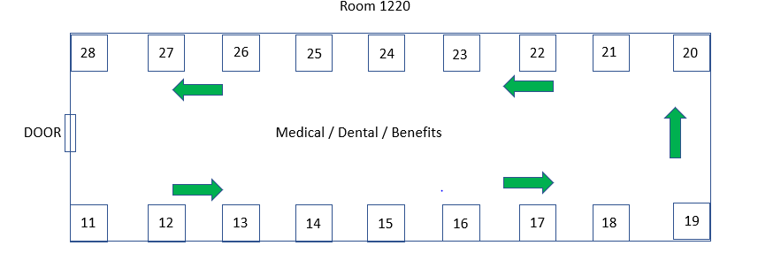

**Providers:**

Senator McSally Office

VetLink

Caption Call

SAHARA

Women Warriors

Chaplain Day

Sonora House

Community Partners Integrated Healthcare

Community Based Outreach Center (CBOC)

Veterans Outreach

Body Wise

Homes for Heroes

Arizona Housing Coalition

DAV Fry Chapter 14

Nancy Brua Animal Shelter

AccentCare

Be Connected

Soldiers Best Friend

VA Center (Minority Vet program)

VA Center (Suicide Prevention)

Chiricahua

CSV S3

Boulder Crest

WACVA/AWU

Primavera

AZ Recovery and Rehab

**Job Fair:**

Jacobs

Goodwill

Thunder Mountain Enterprise

SOSI

Pima County Sheriff’s Office

Iron Bow Technologies

Landmark Metal Builders

State of Arizona Department of Corrections

Direct VIZ Solutions, LLC

Neaman Solutions, LLC

